# TABLE OF CONTENTS

**TABLE OF CONTENTS** **1**

**Geographical Plot Structure** **1**

**Threshold** **1**

**Visuals** **3**

**Diversity Measures** **13**

**Climate and Urban Areas** **21**

# 

# Geographical Plot Structure

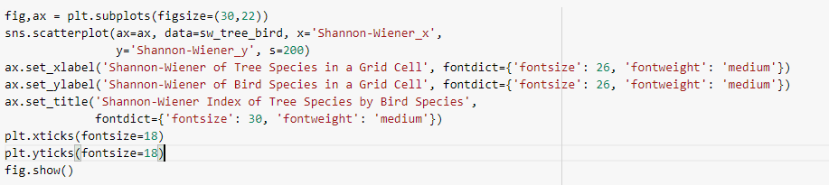

# Threshold

THRESHOLD

BIRD >= 50 (sum of individualCount for bird)

TREES >= 10 (tree observations)

Figure 2

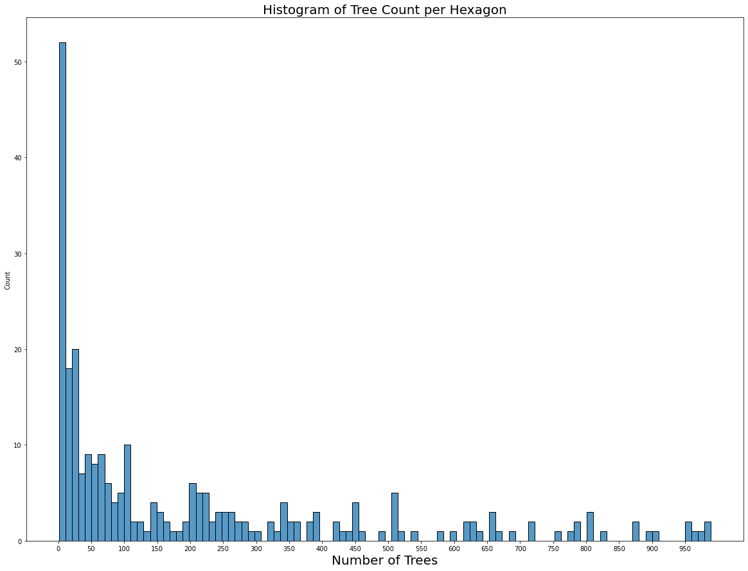

Figure 3

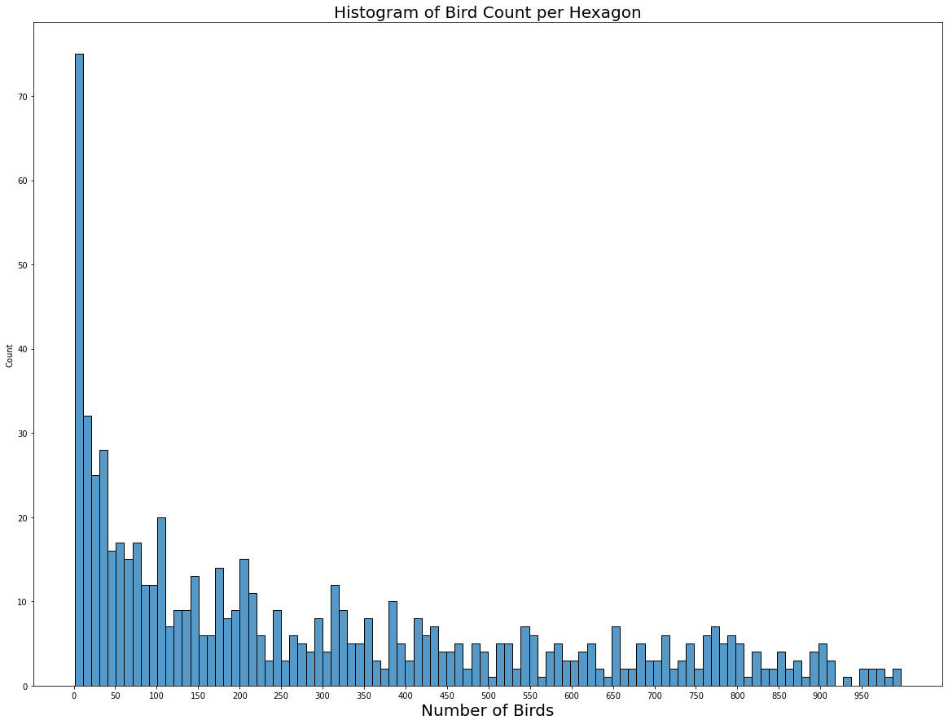

# Visuals

Figure 3

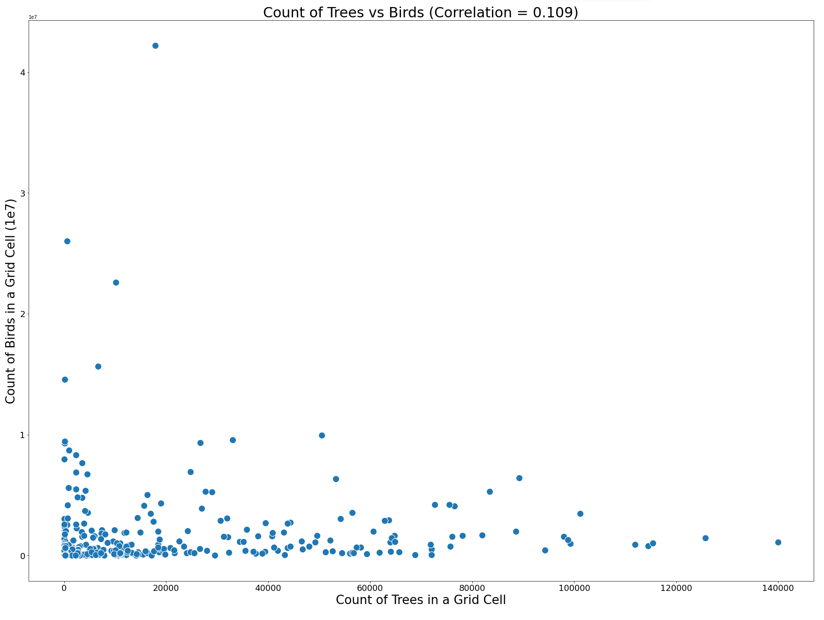

Figure 4

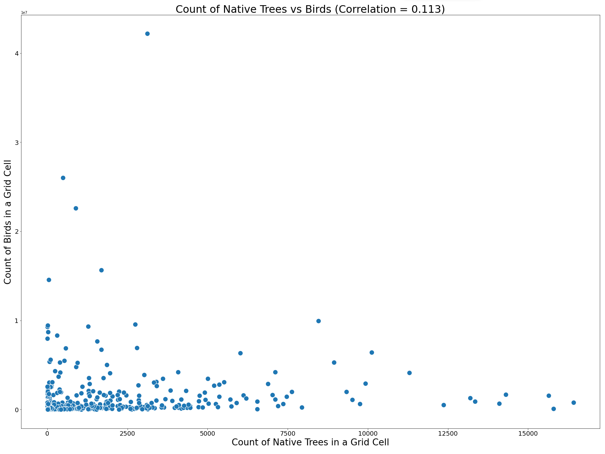

Figure 5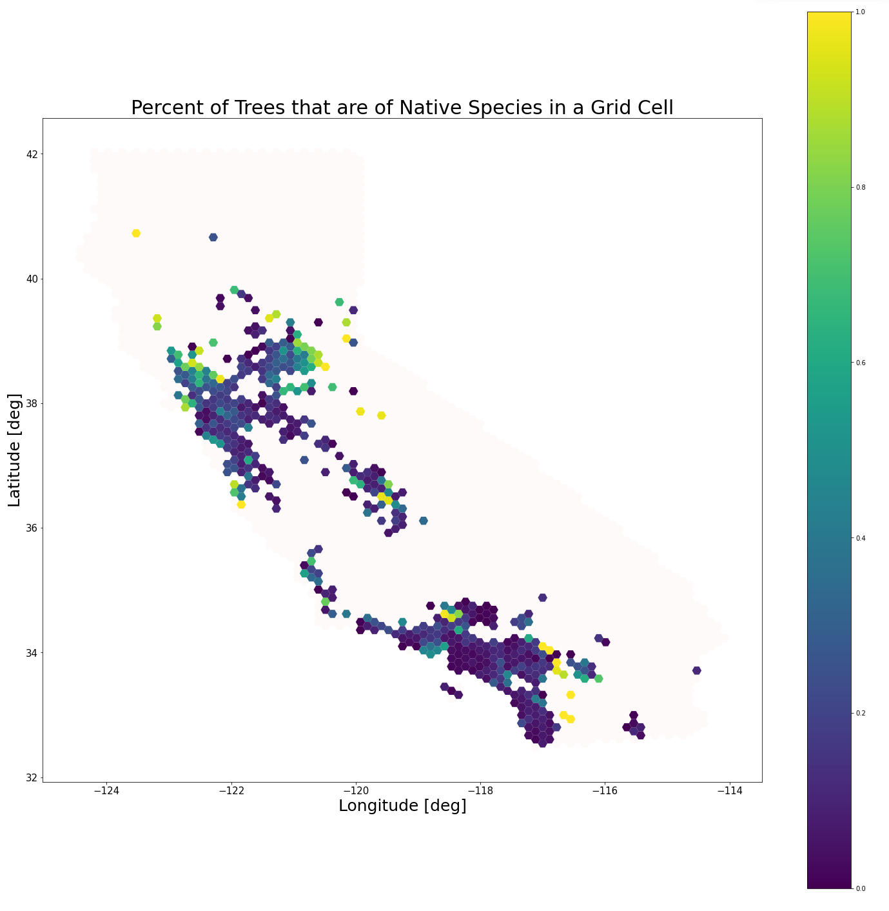

Figure 6

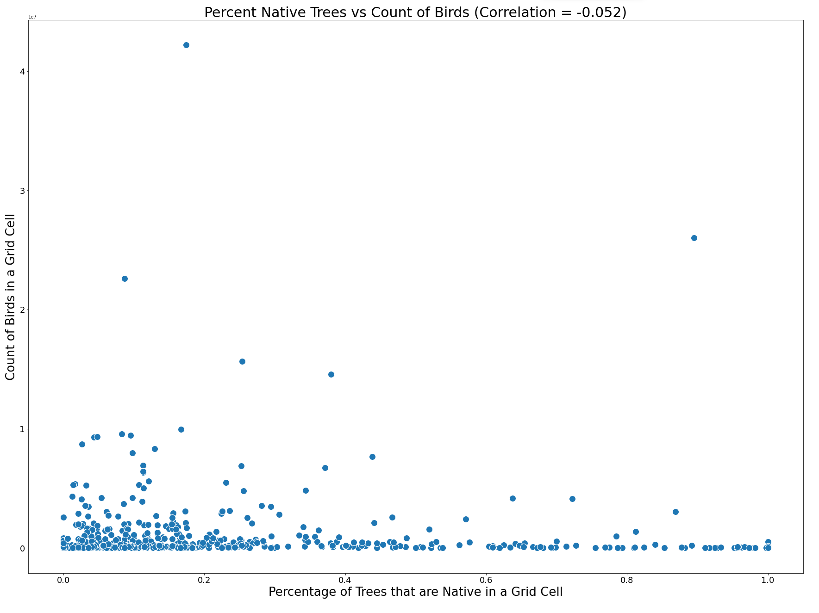

Figure 7

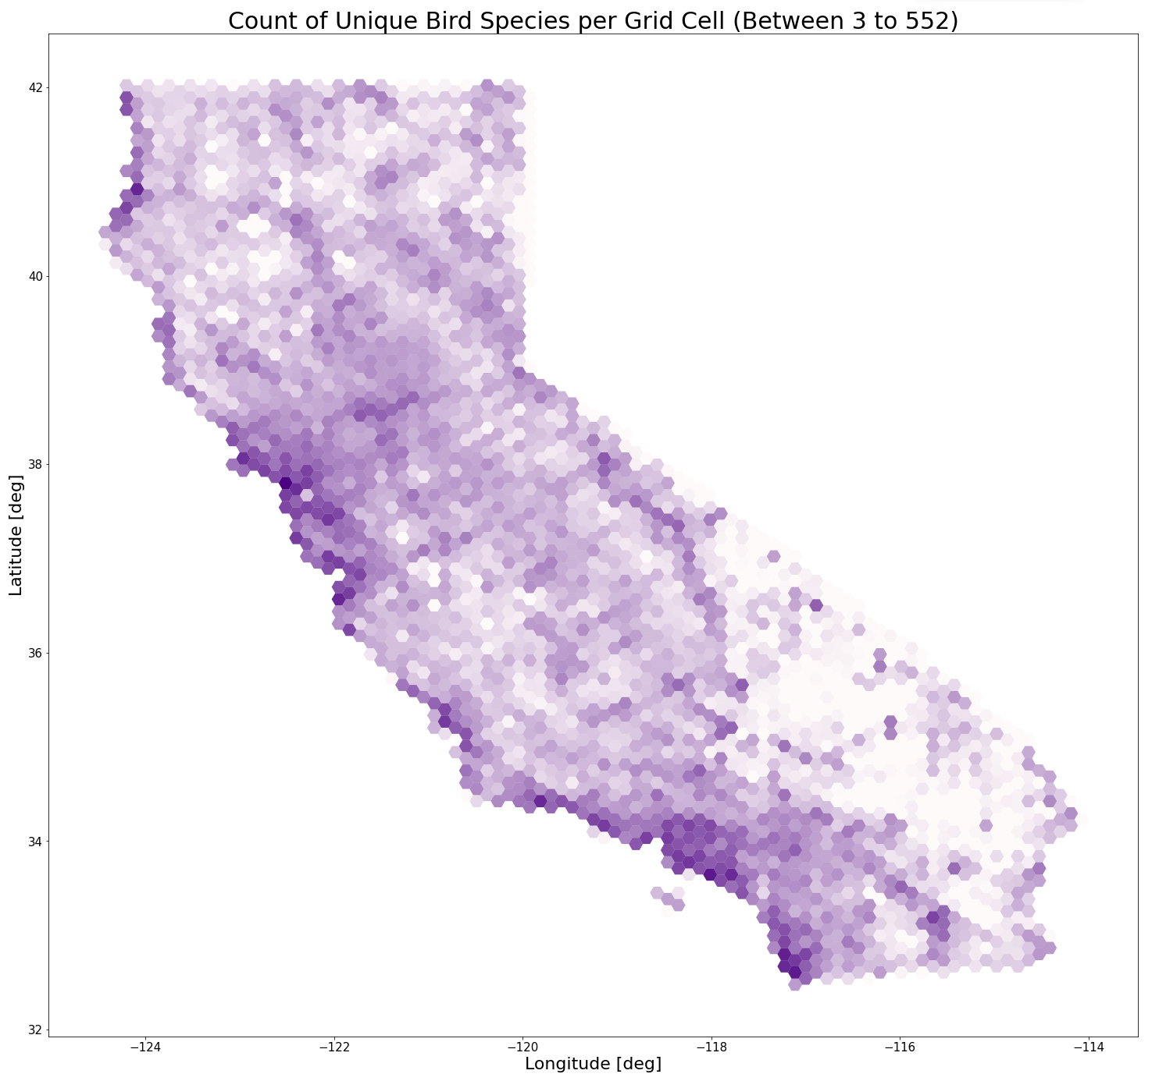

Figure 8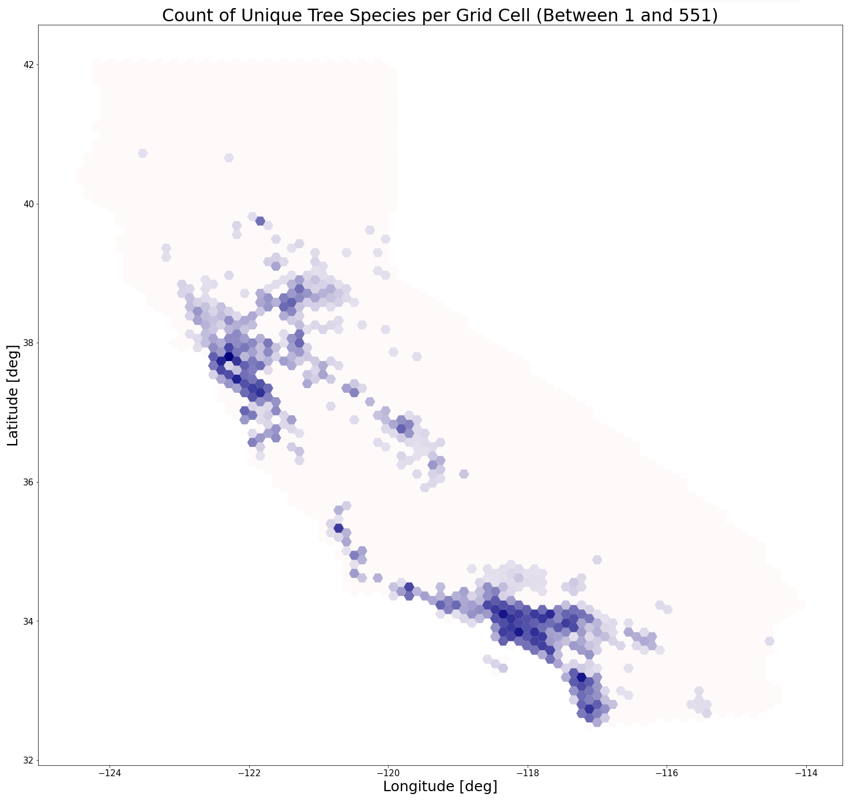

Figure 9

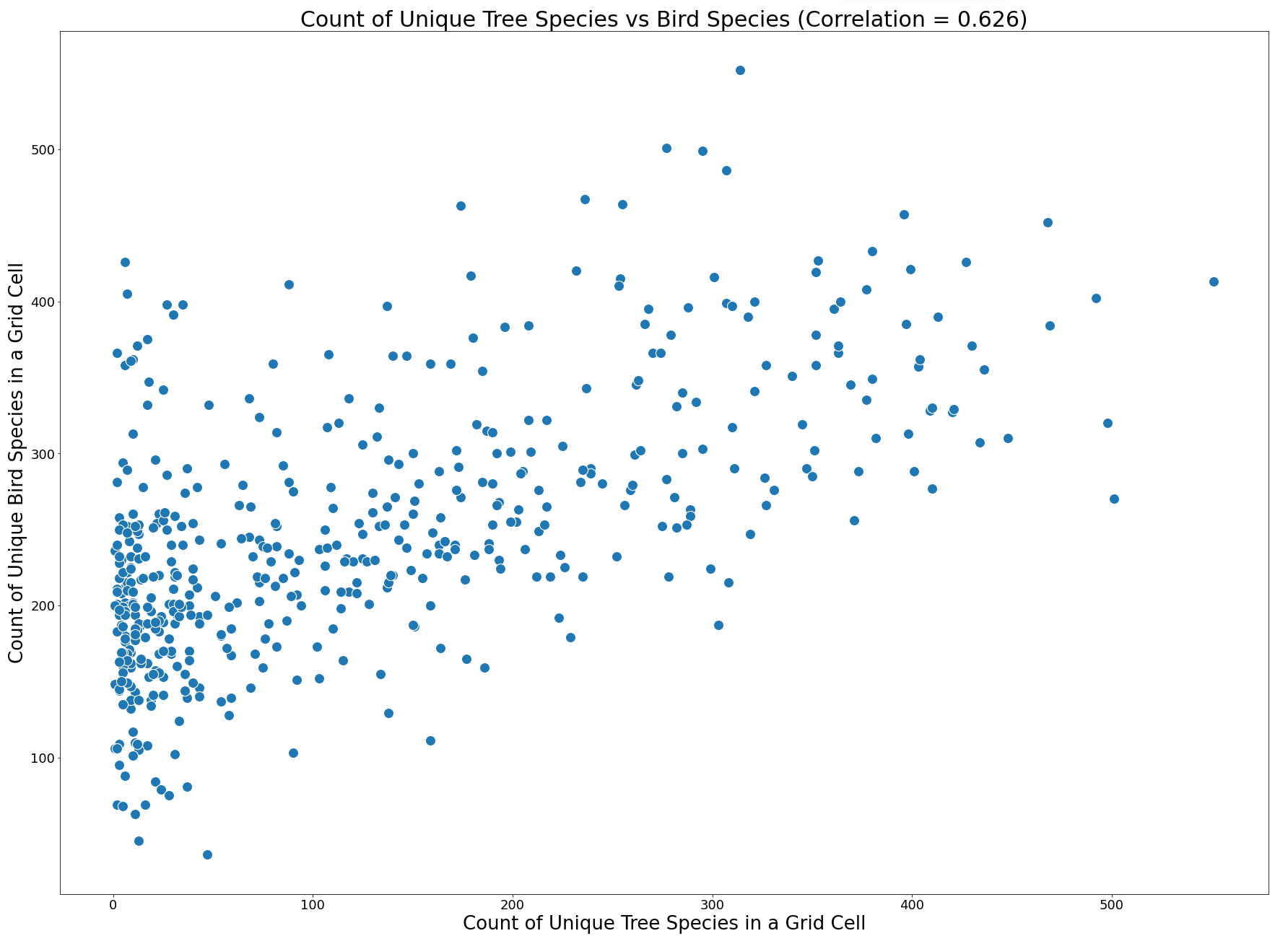

Figure 10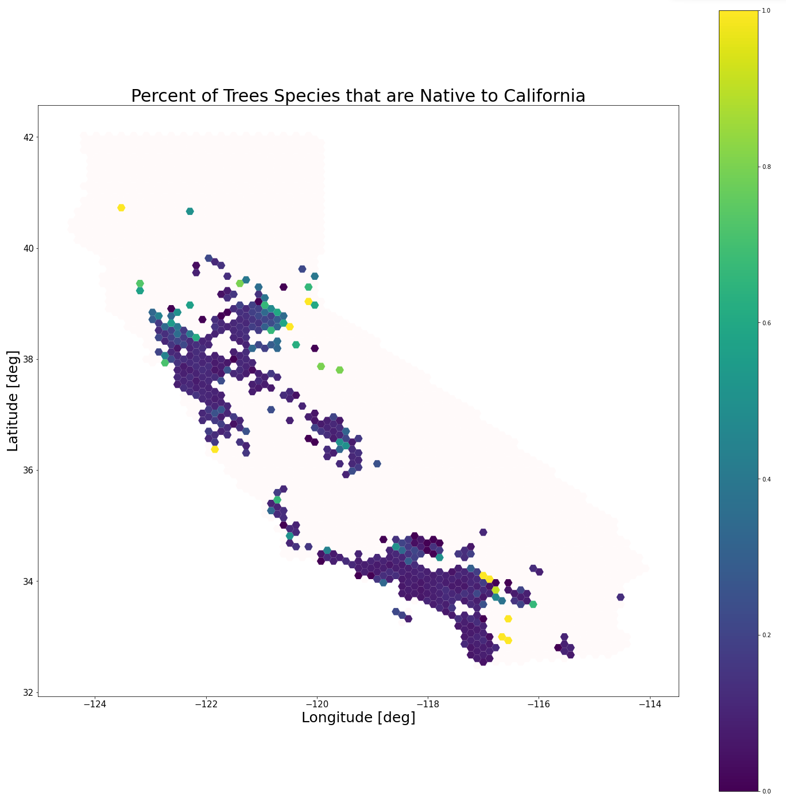

Figure 11

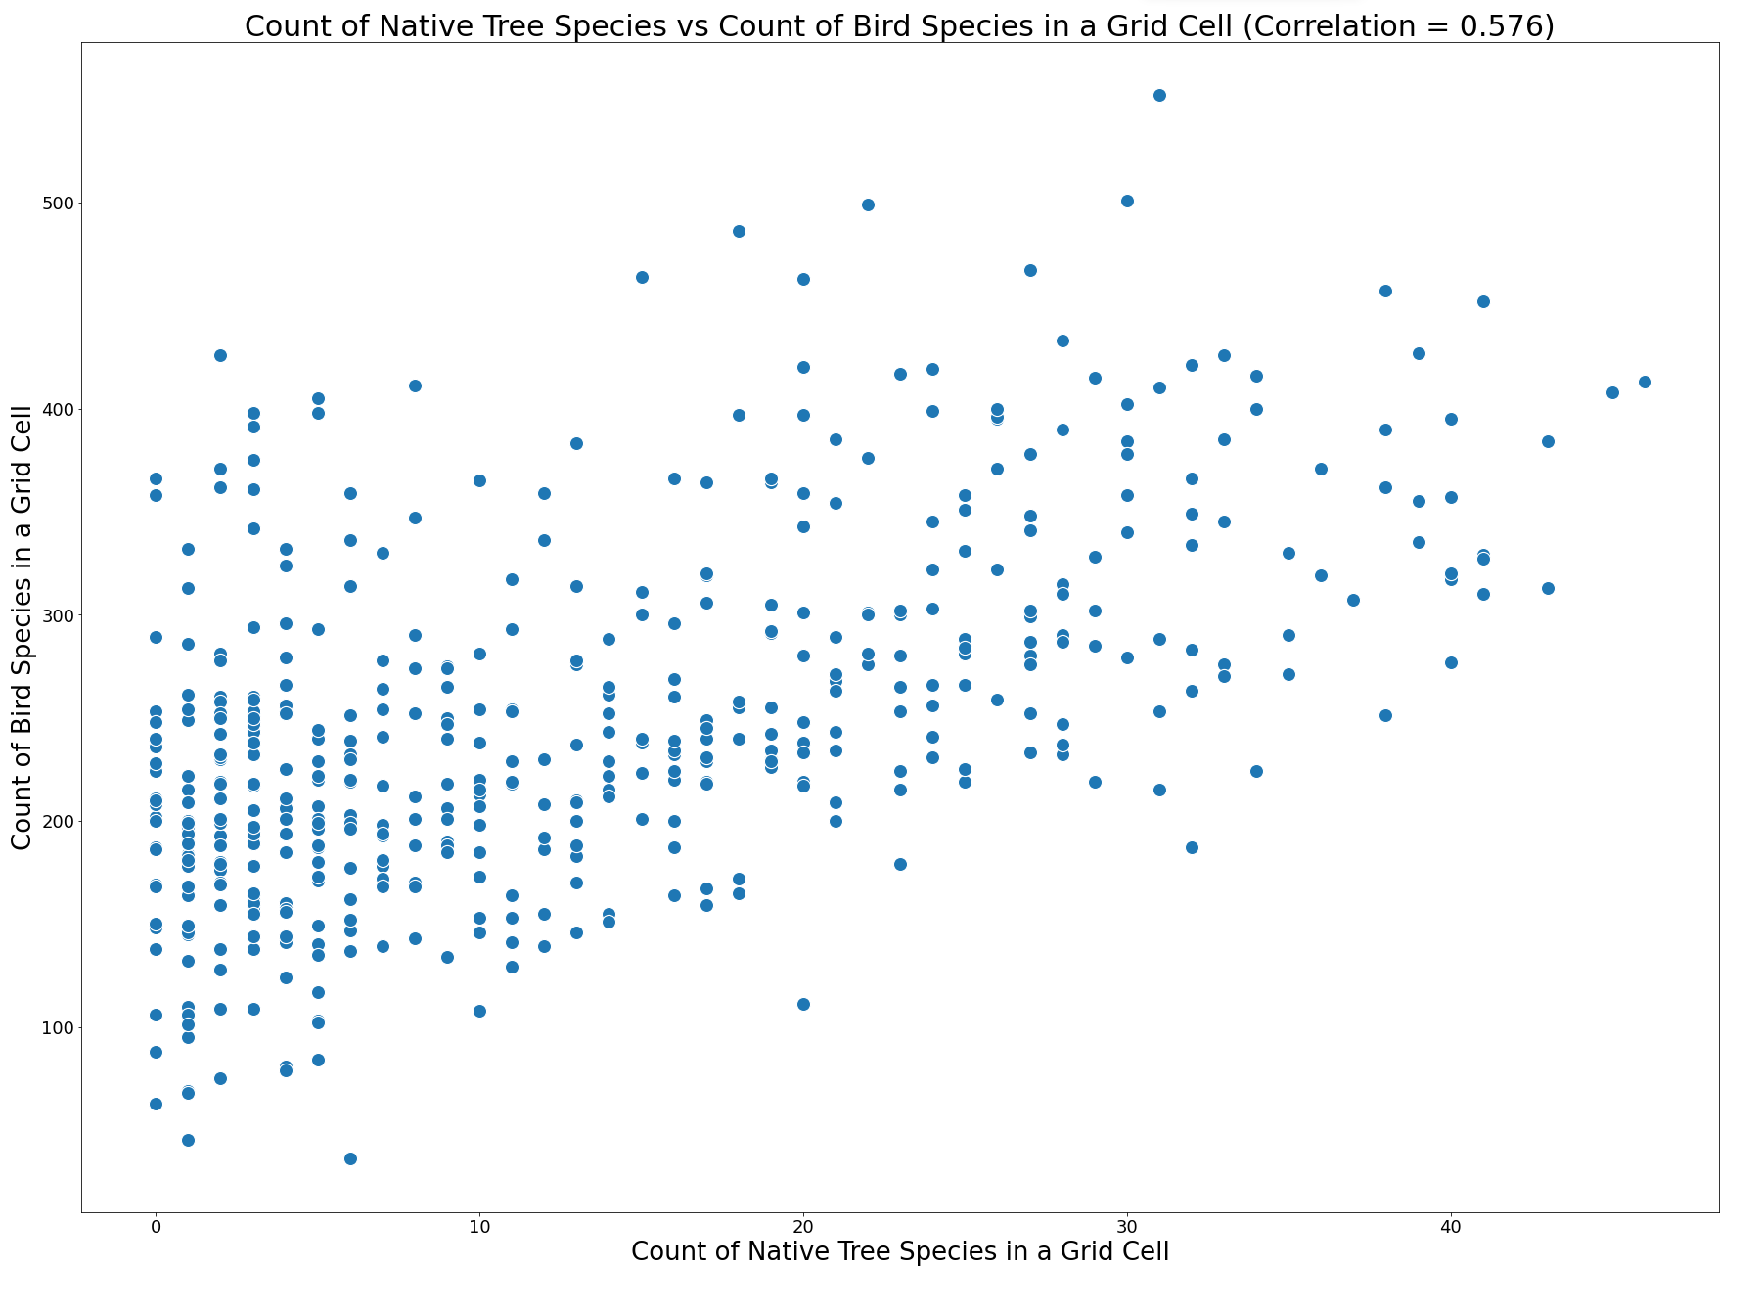

Figure 12

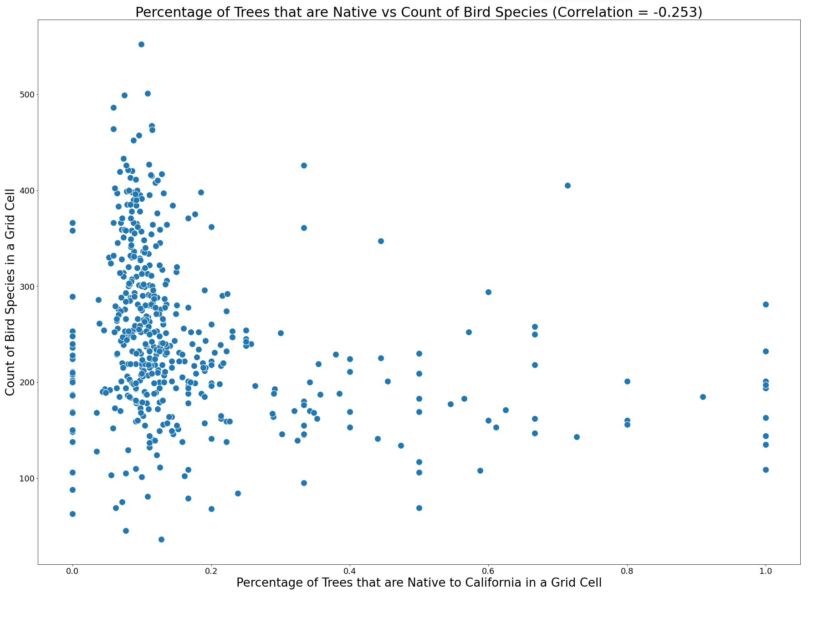

## Diversity Measures

Figure 13

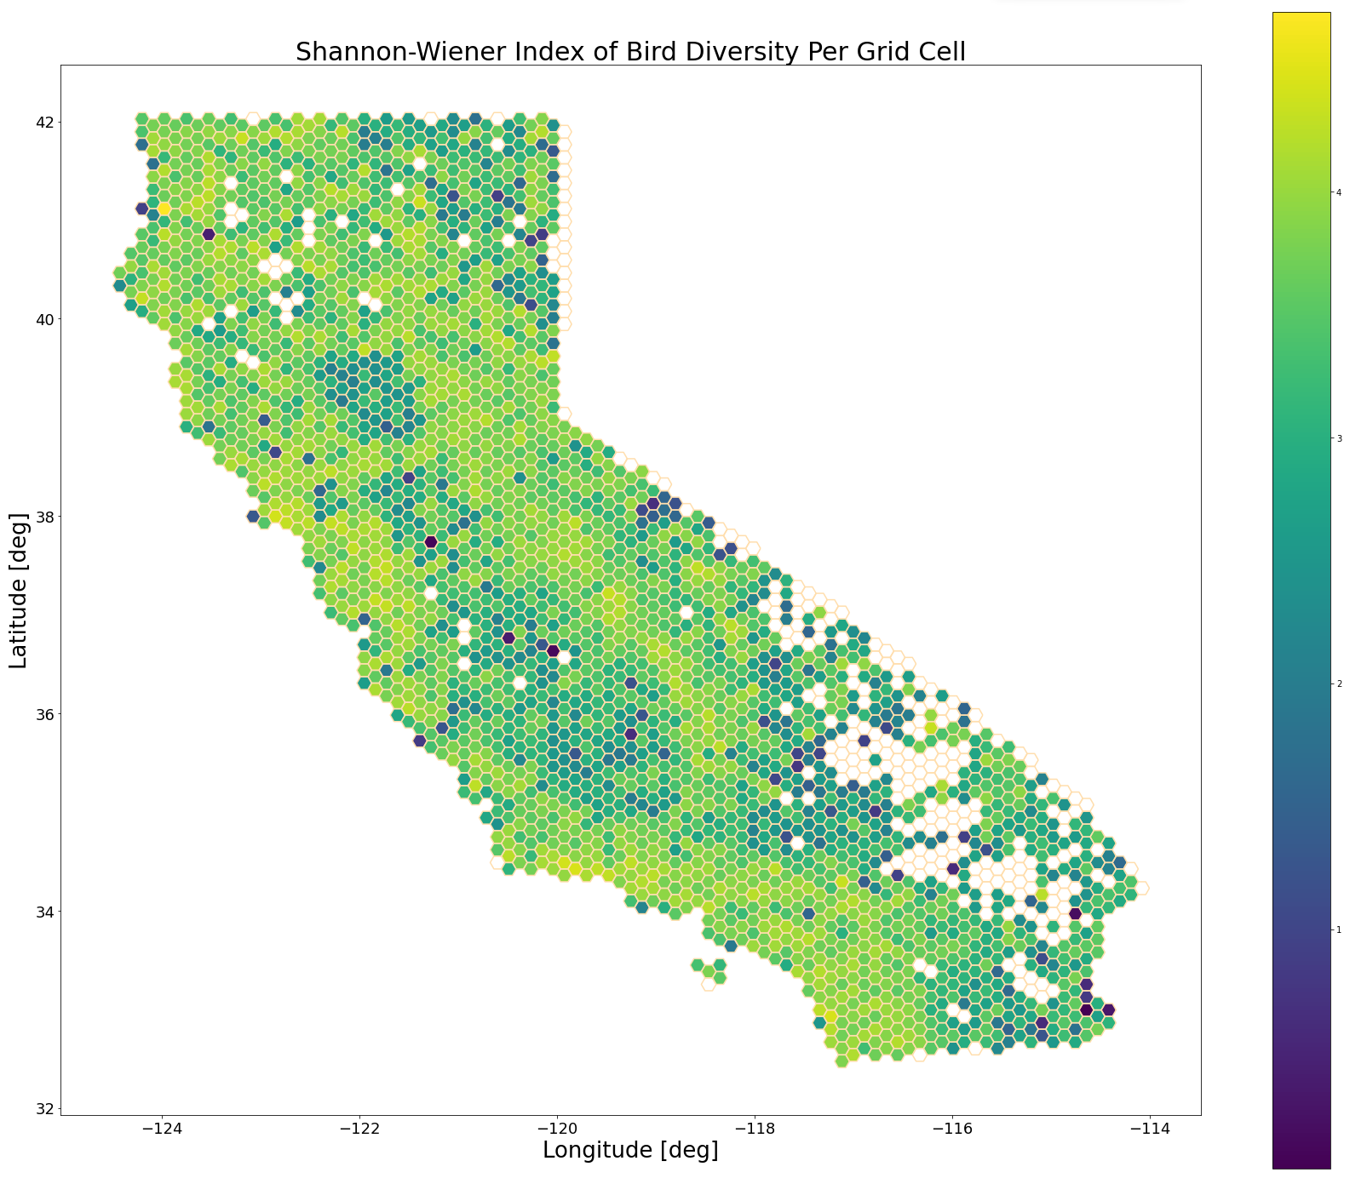

Figure 14

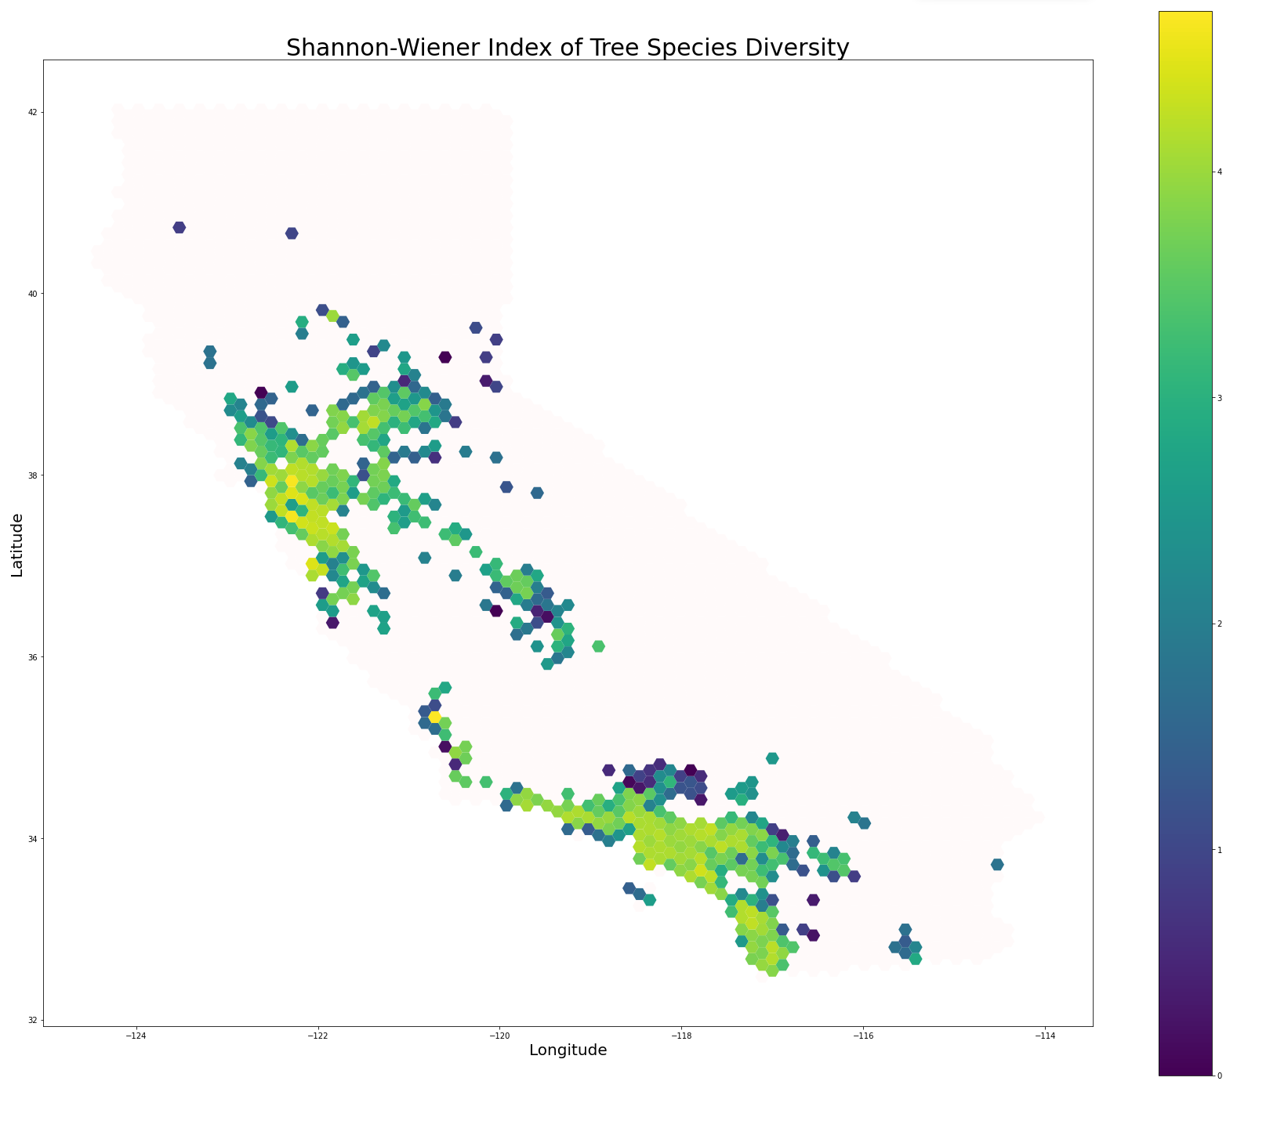

Figure 15

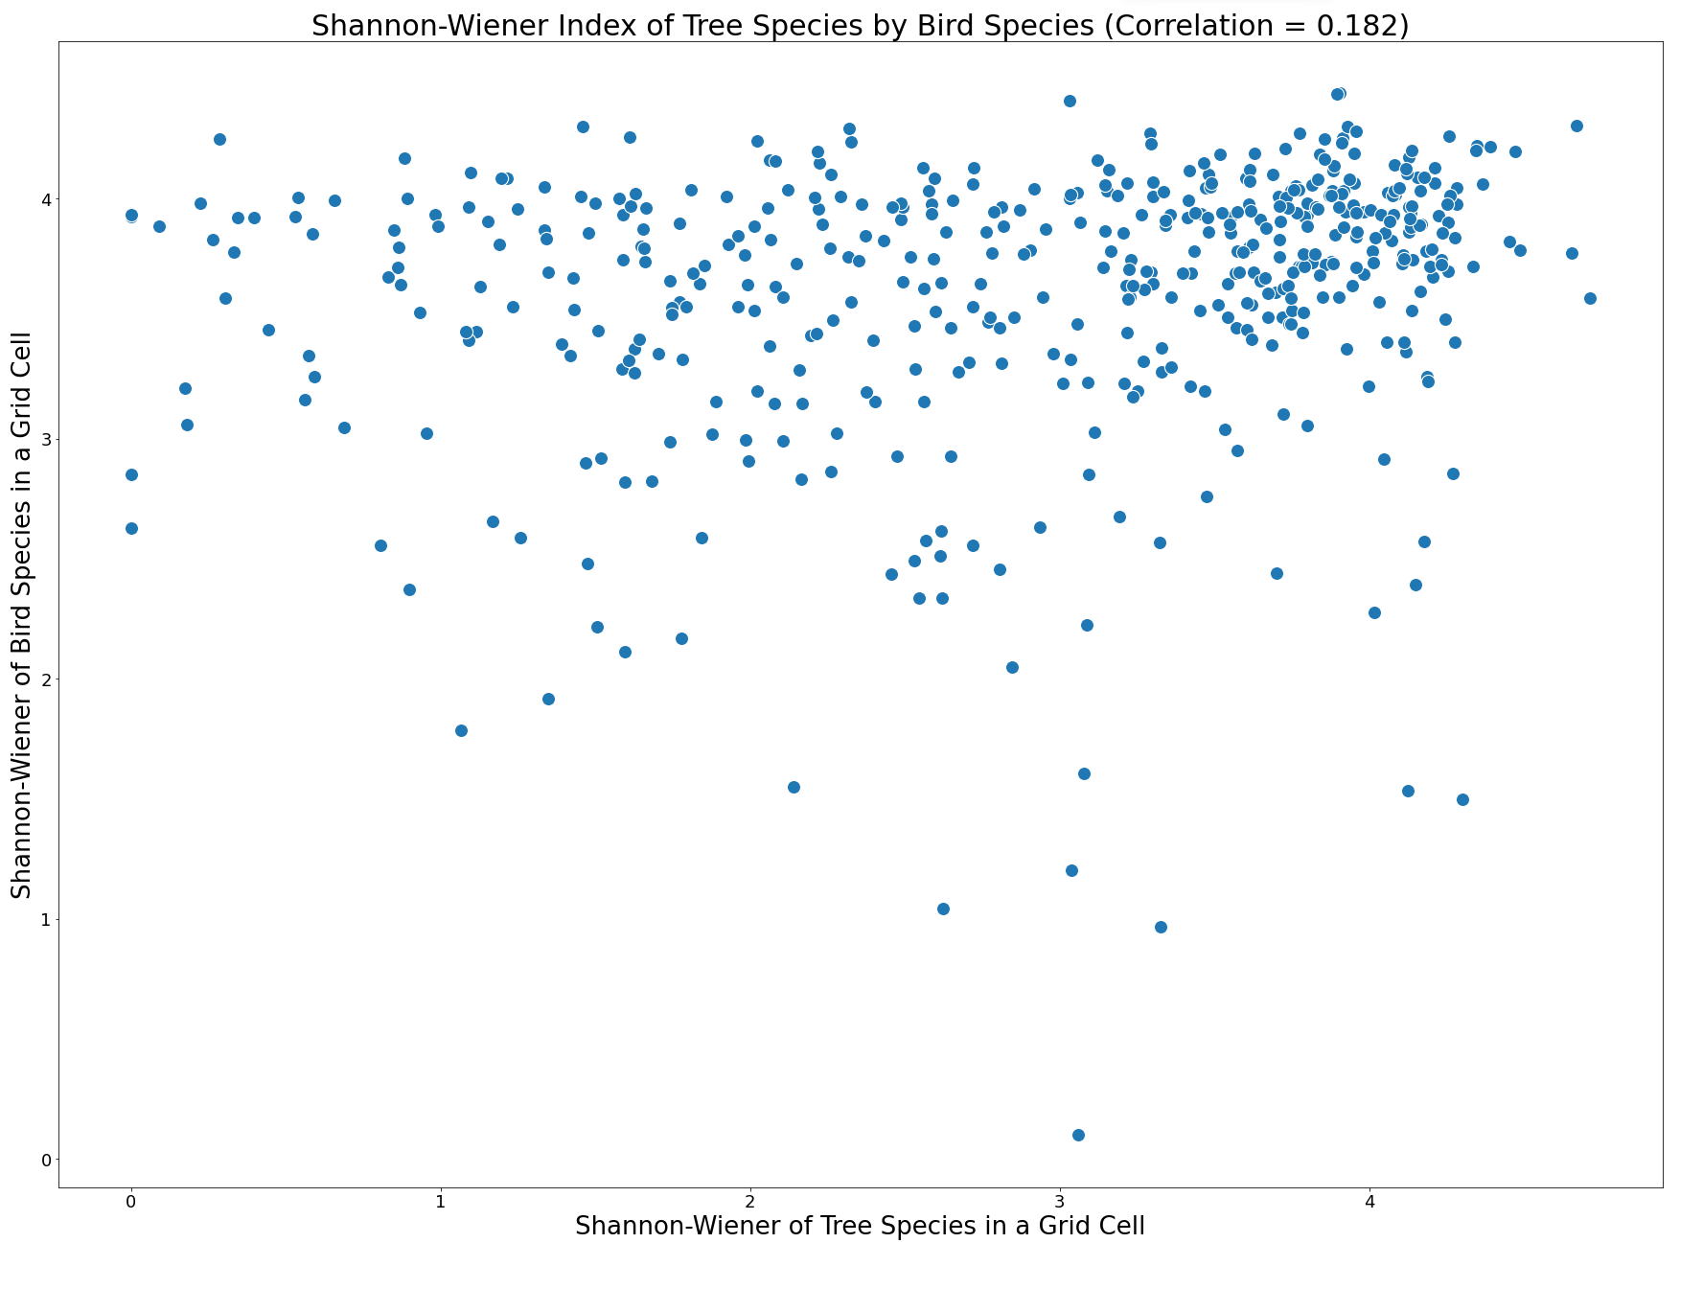

Figure 16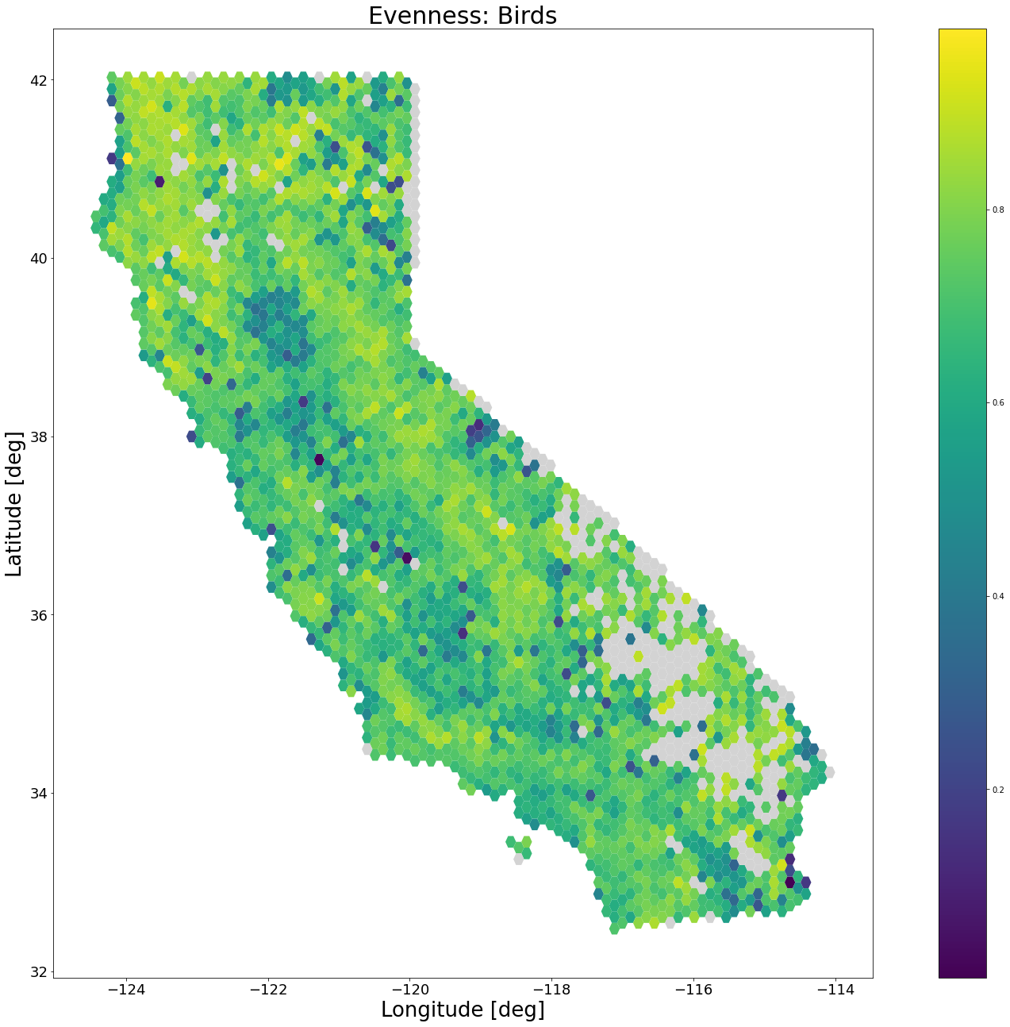

Figure 17

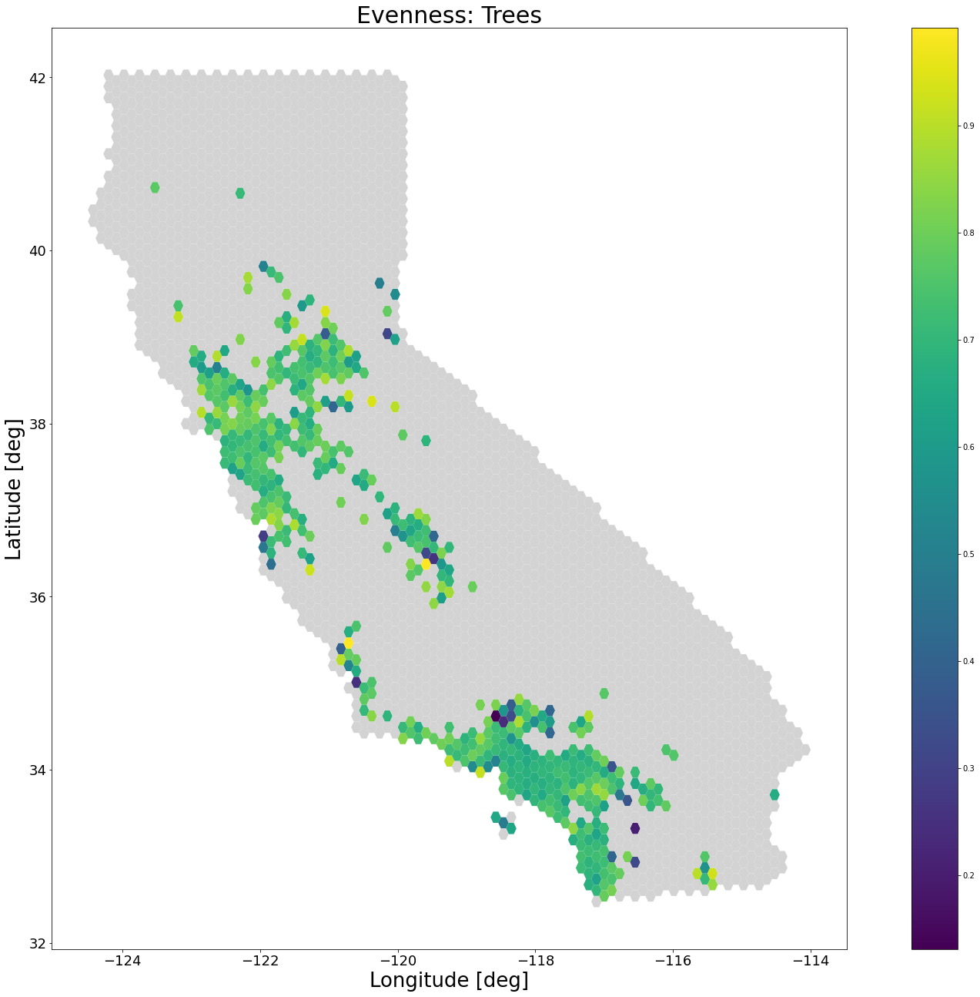

Figure 18

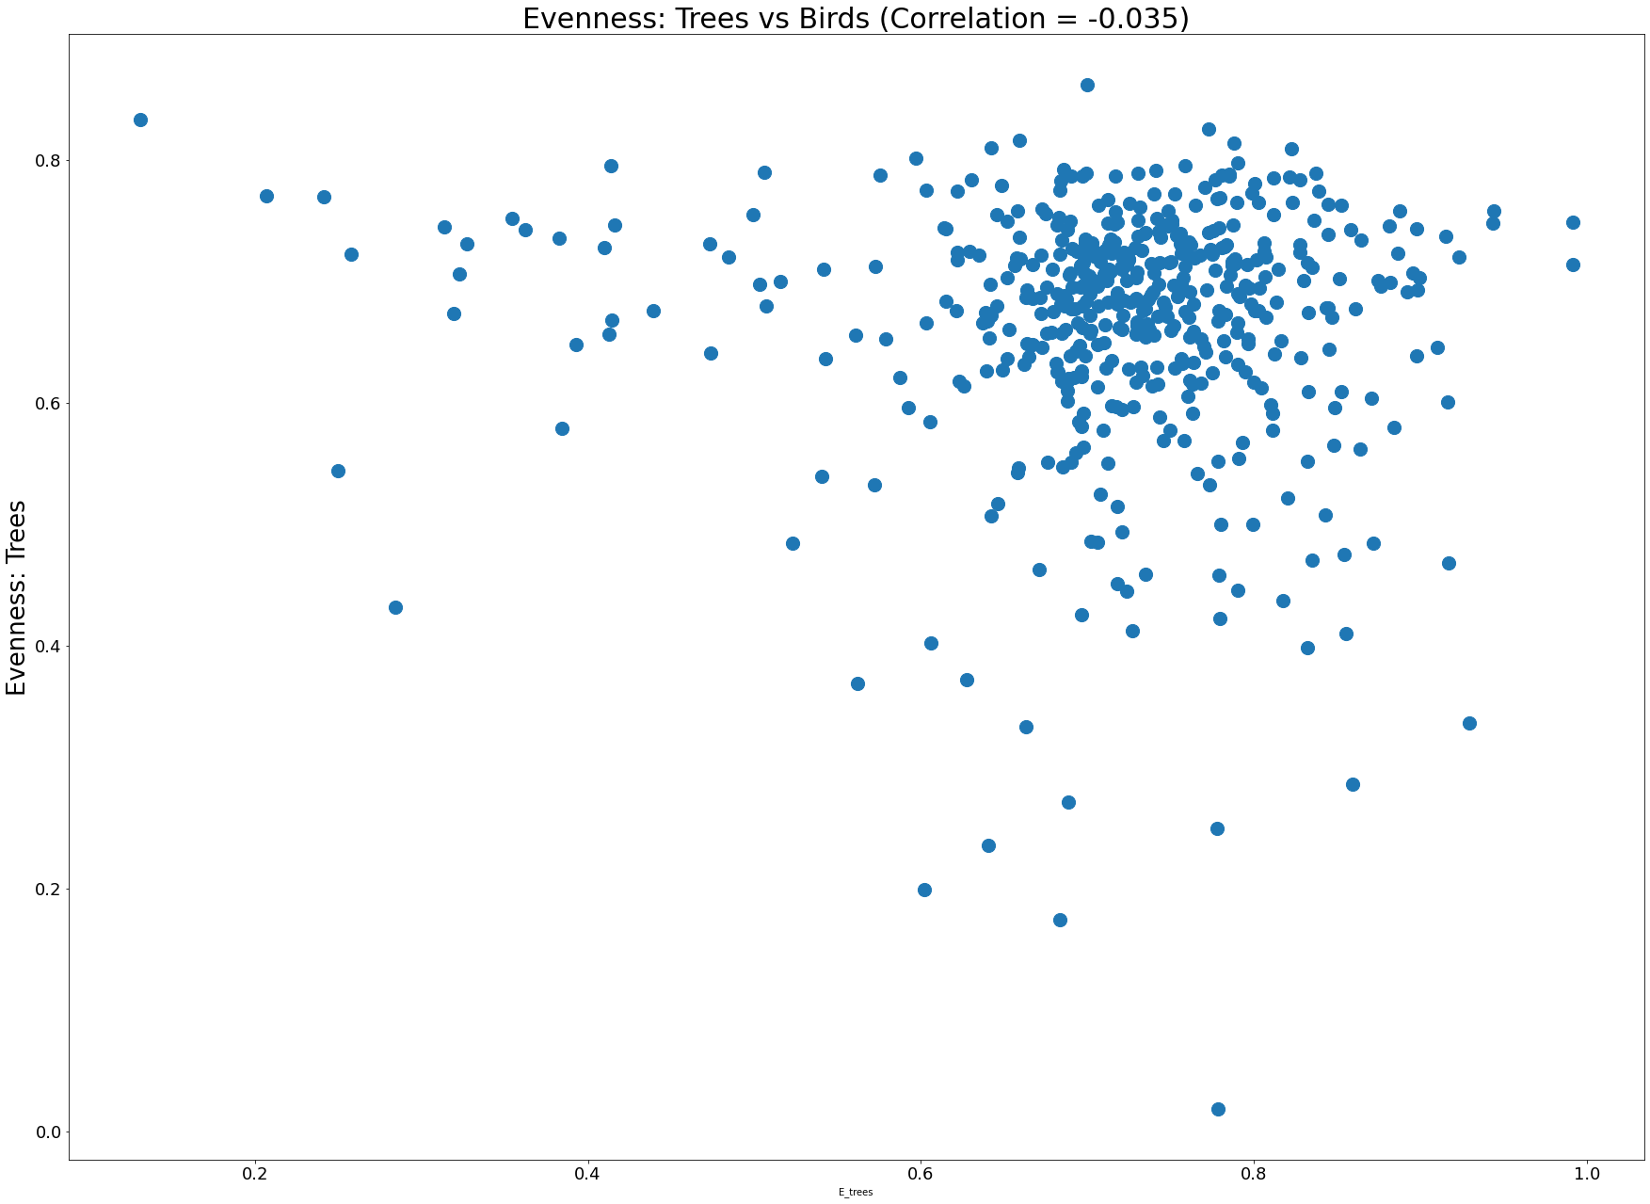

​​

Figure 19

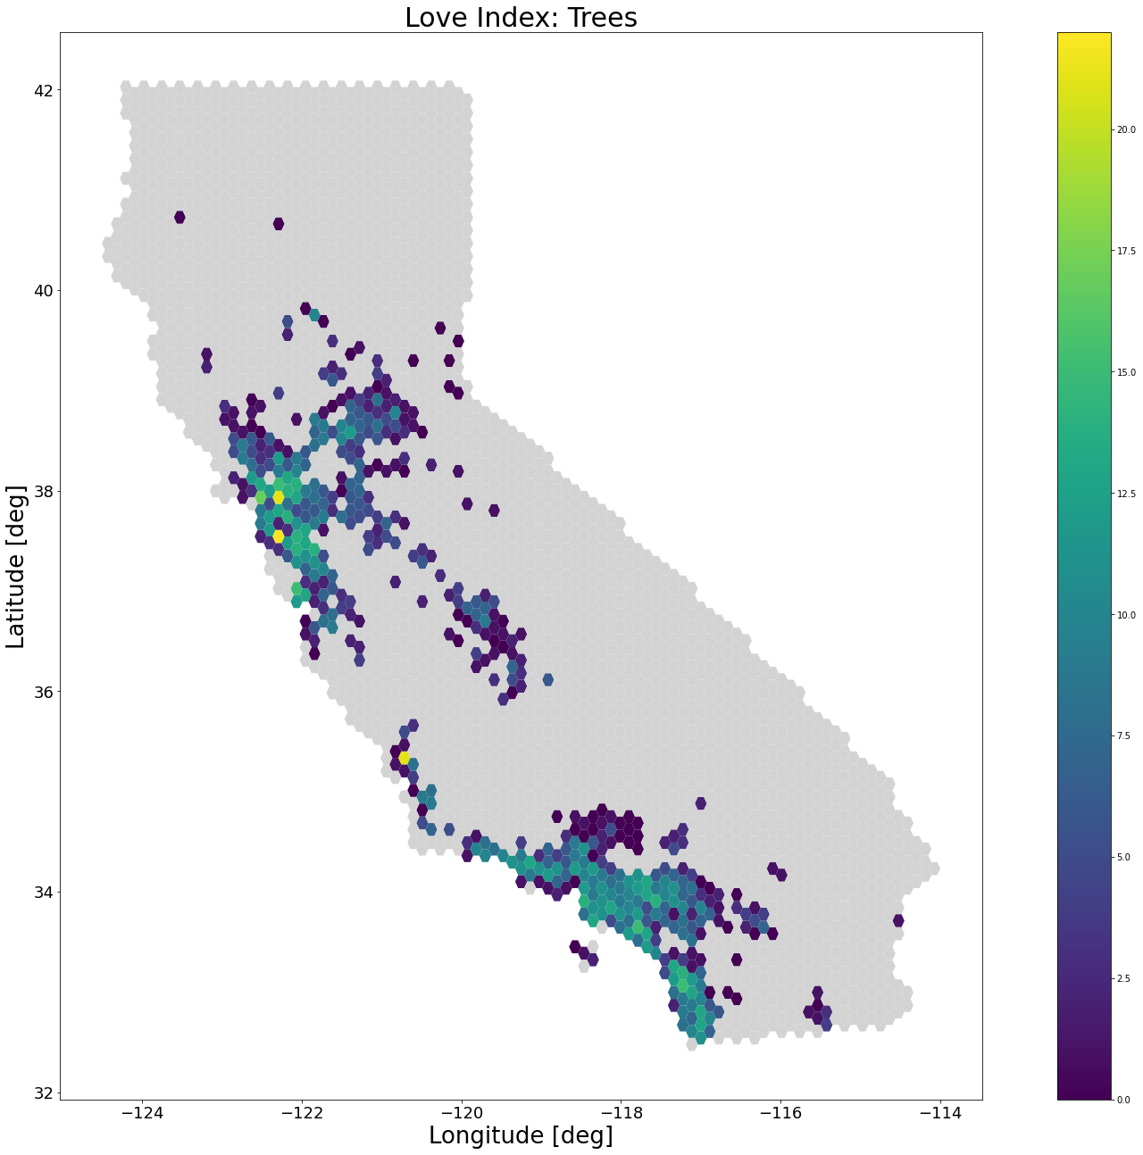

Figure 20

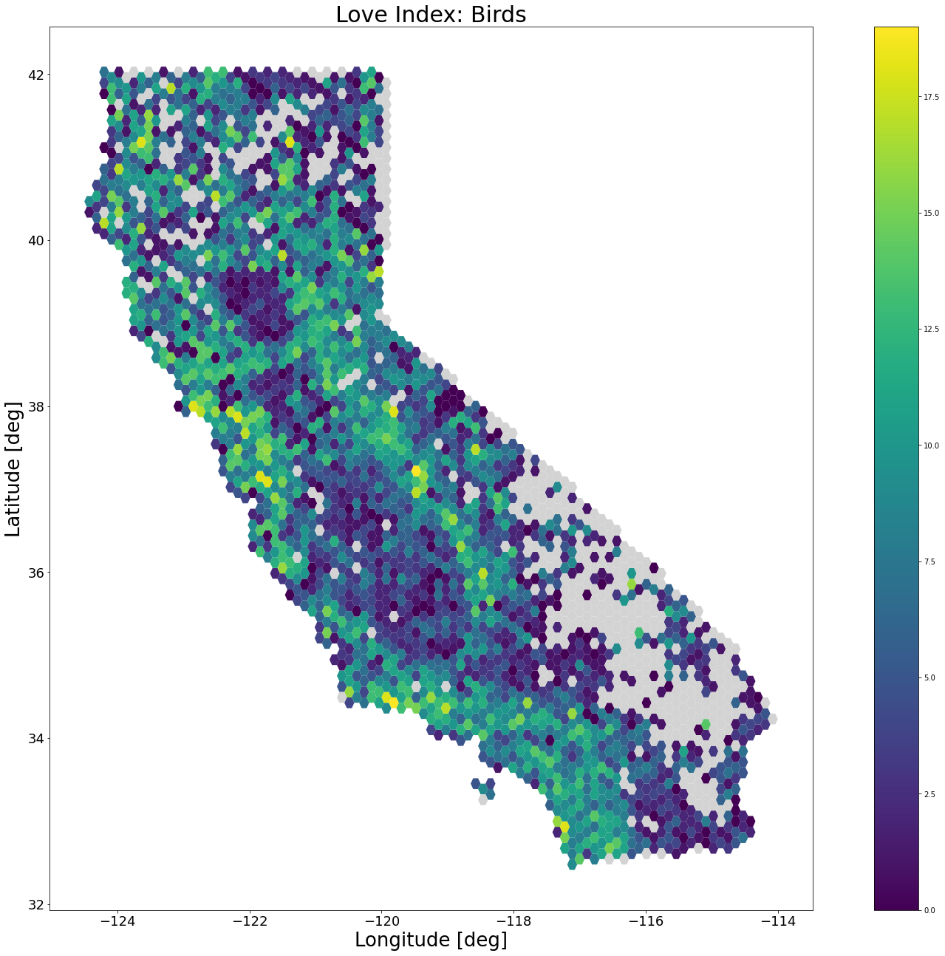

Figure 21

(Darker dots are more frequent)

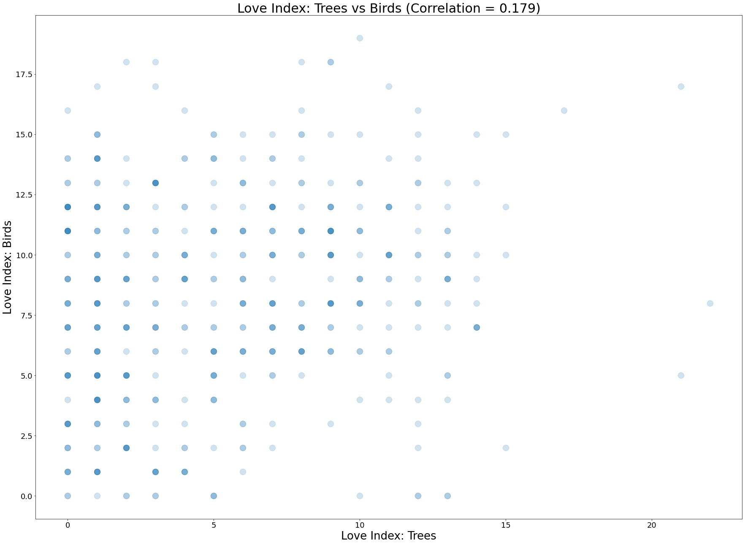

## Climate and Urban Areas

Figure 22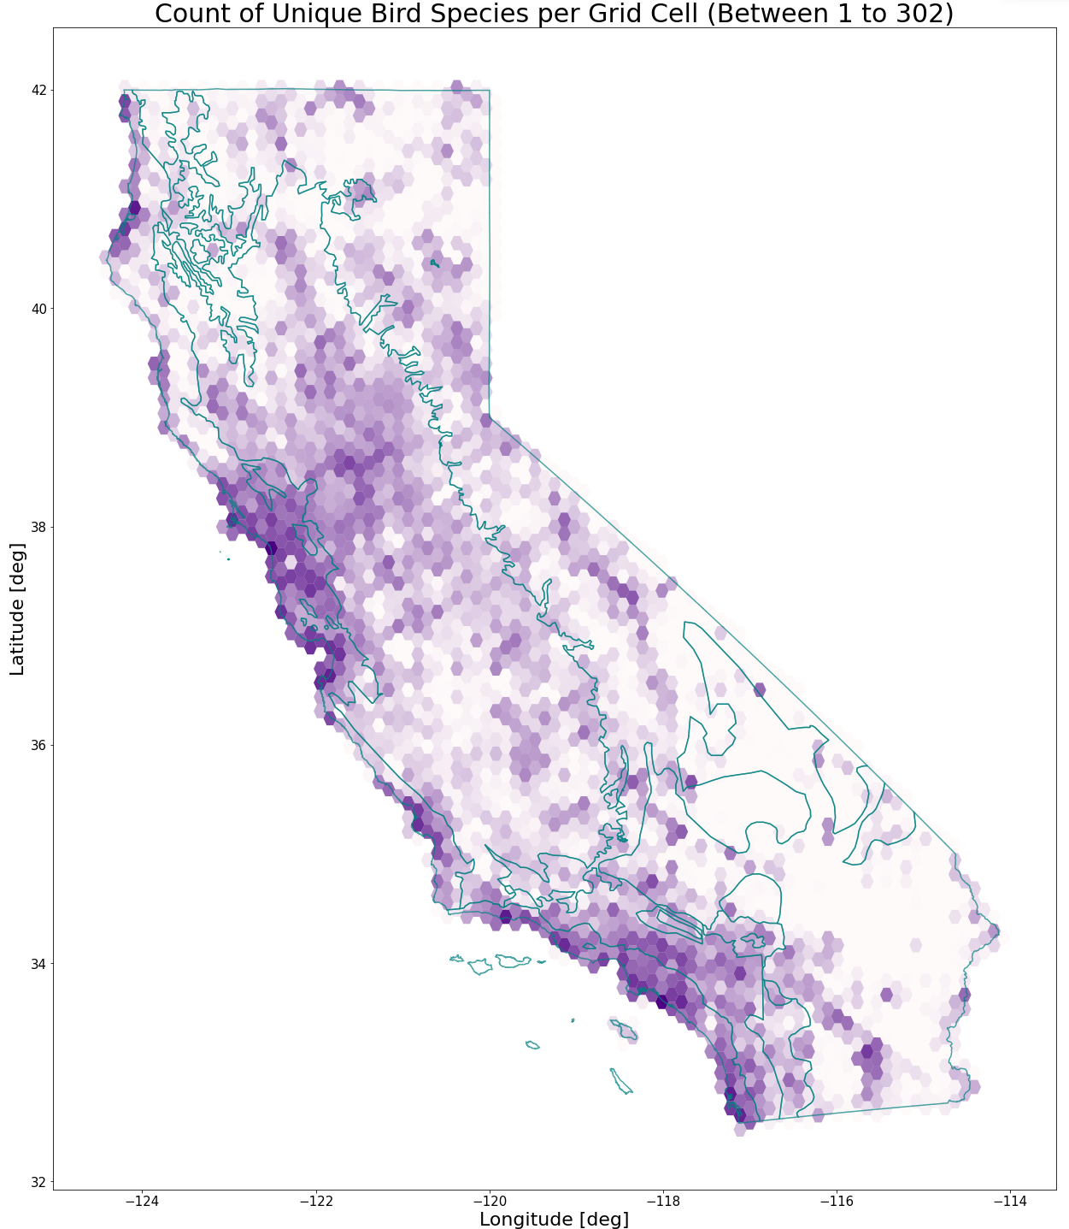

Figure 23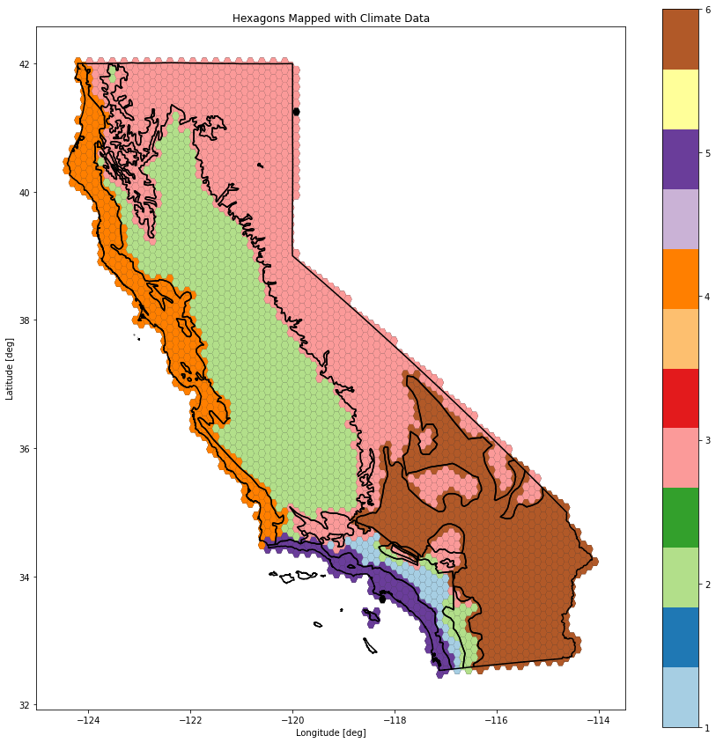

Figure 24